Animal Parts
Aim: students will be able to recognize common animal parts, in contrast to parts of the human body. Higher students will be able to say what an animal has.
Lexis:
Horn claws fins fur gills
Scales a shell spots stripes wings
fangs feathers a beak a tail
It has _______

Method - warmer
Draw an animal (lion) on the board.
It has _____ (a head, a tail, …)

Go through target language , For example, Horn, what animals have a horn… horns?
Elicit ideas… and show flashcards – write up one animal

Drill pronunciation of body part and leave f/c or picture on board
Games - body parts matching game
Once all body parts have been introduced, [leave diagrams on board] tell them the
Split class into groups of 4 students (5 teams of 4)

For each team: (see materials below)
have a bag with the 12 body part pictures at back of the class
sheet with the 12 animal part words in the middle of the class

Teams line up at the front – they take it in turns to run to the back, pick out a picture and then run to middle and try to match that picture to the correct word
When they get back, the next person in the team can go
Once they have finished, I let them check their answer before declaring them a winner or not

Creepy Animal Game
Each student has a piece of paper/notebook.
Bring one student from each group to the front, they then roll the dice and pick up a piece of paper from the “Body Parts Bag” (include eyes, legs and arms)
They tell their team and everyone has to draw that number of body parts onto their Monster.
(5 shells… 1 beak…. )
Give each student one or two goes each before stopping and comparing monsters – ask ss questions about the monsters (i.e. describe your monster… or how many wings does it have… depending on level/ability)

Spots
A Wing
A Shell
Gills
Scales
Fur
A Claw
A Fin
A Horn
Stripes

Fangs
Feathers
A Tail
A Beak

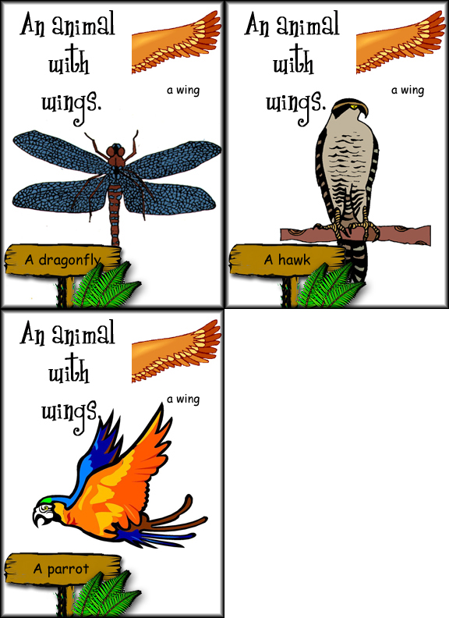 | 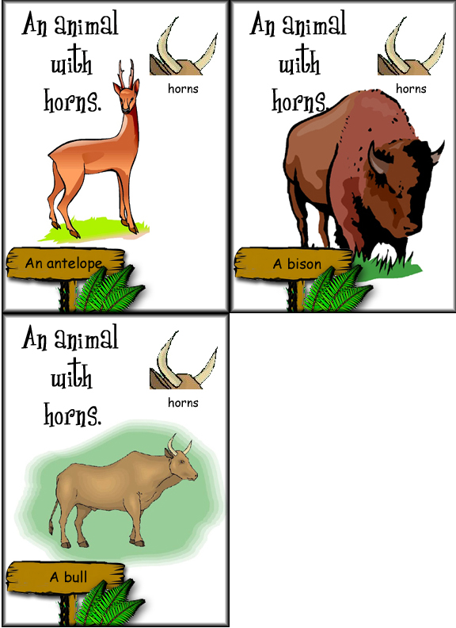 | 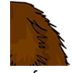
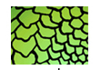 | 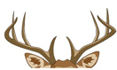 | 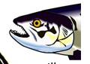
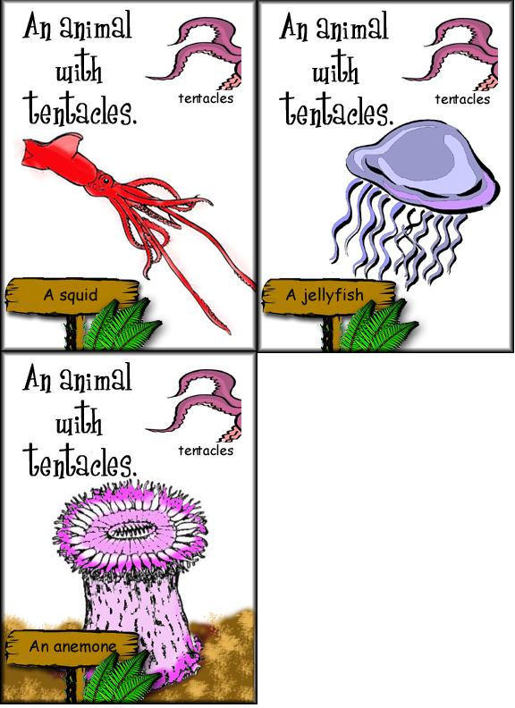 | 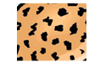 | 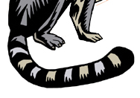
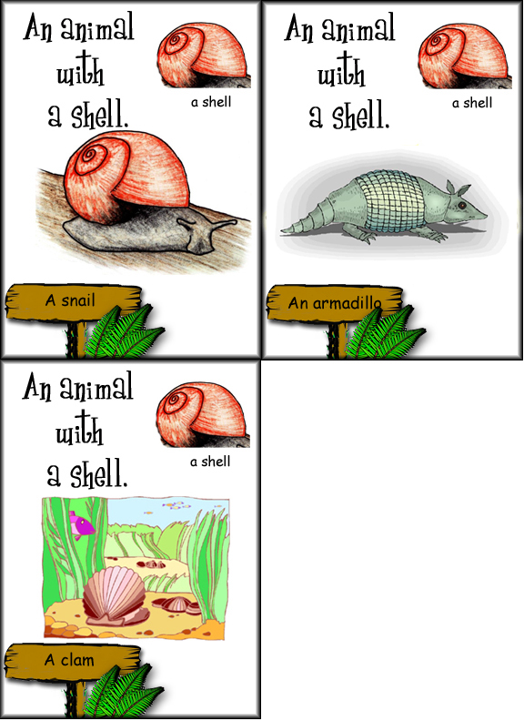 | 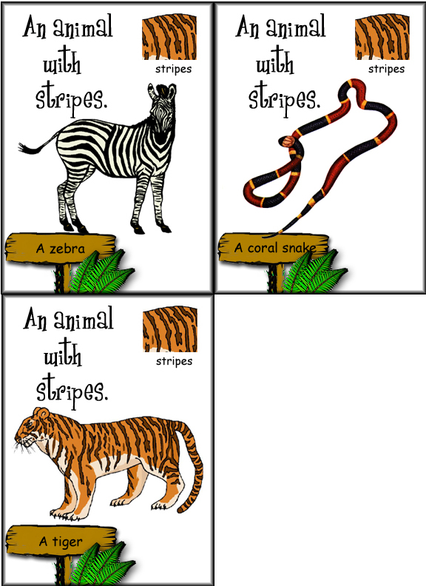 | 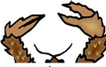
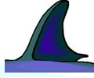 | 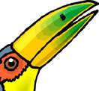 | 

